|  |
| --- |
|  |
| TransACT User Manual |
|  |
|  |

**Rose-Hulman Institute of Technology**

2017

Authored by: Garrett Barnes, Tayler How, CJ Miller, Emily Richardson, Jesse Shellabarger

TransACT User Manual

Table of Contents

Contents

Getting Started 2

Creating a New Database File and Password 2

Working from an Existing Database File 3

Using TransACT 4

Operations Tabs Overview 5

Account Operations Tab 5

Transaction Operations Tab 5

Miscellaneous Tab 5

Creating a New Account 6

Importing Transactions into an Account 7

Using the Ignored Editor 9

Manually Adding Single Transactions 11

Using the Add Transaction Window 11

Adding Transactions through the Right-Click Menu 12

Deleting 13

Deleting Transactions 13

Deleting Accounts 14

Automatically Adding Tags to Imported Transactions 15

Editing the Table View 17

Filtering Transactions 18

Filter by Search 18

Filter by Selecting an Account 18

Undoing Actions 19

Analyzing Finances 19

Filtering 20

Different Charts 21

Expenditure Line Chart 22

Expenditure Pie Chart by Tags 23

Expenditure Pie Chart by Payee 24

Income Bar Chart 25

Net Balance Line Chart 26

Exporting Data 27

Logging Out 28

# Getting Started

Welcome to TransACT! This manual is designed to guide first time users through the TransACT finance management software. It provides instructions on how to navigate and use the software properly.

## Creating a New Database File and Password

When using TransACT for the first time, the first thing you will need to do is create a new database file that will serve as a storehouse for all your transaction information. To do this, click the “New File” button on the login screen as shown below.

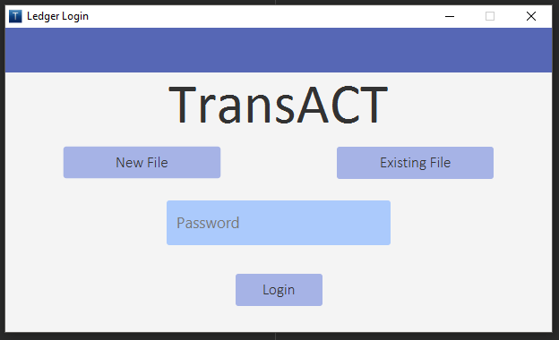

The “Create New File” window will appear. Create a password that you will remember and enter it into the two password text fields. This password is used to log into this user session after you’ve logged out or closed the application. Then, click on the “Select Location” button.

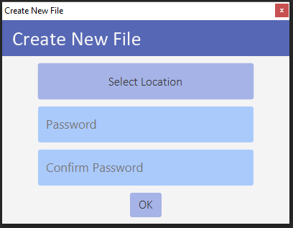

A window similar to the one shown below will then appear. Place the file wherever you want, and feel free to rename it. Click “Save” when you are done and you will return to the Create New File window. Click the “OK” button to continue. The application will automatically log you into your first user session!

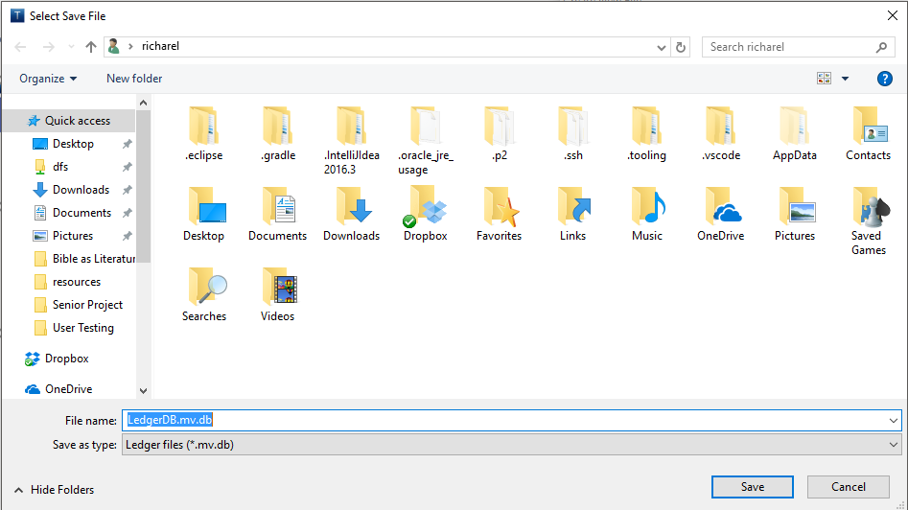

## Working from an Existing Database File

If you have already created a database file and would like to return to the user session associated with it to manage further the finances within, then select the “Existing File” button on the login screen, shown below.



A window like the one shown below will appear and allow you to select your previously used database file. Once you have selected the file, click the “Open” button in the lower right corner of the window.

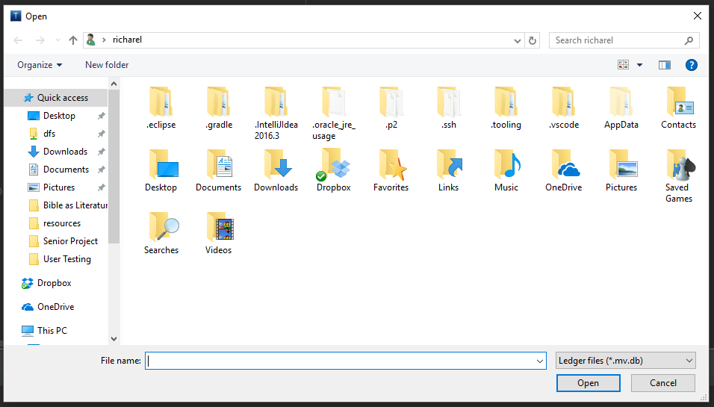

The name of the file will appear on the button that formerly said “Existing File”. Enter the password associated with that file in the password field on the login page, and click the “Login” button. Your previous user session and all information within will appear as you left it.

# Using TransACT

The main page will appear upon logging into TransACT, as shown below. All transactions that you import from bank statements or add by hand will show up in the transaction table. Each transaction is represented as a row in the table view. The table has several columns to note. Briefly, column headers Date, Payee, Type, Check Number, Cleared, and Amount will contain the corresponding information of the transactions. Other headers such as Tags, Account, and Note represent editable fields that you can manipulate to help the organization of the data.

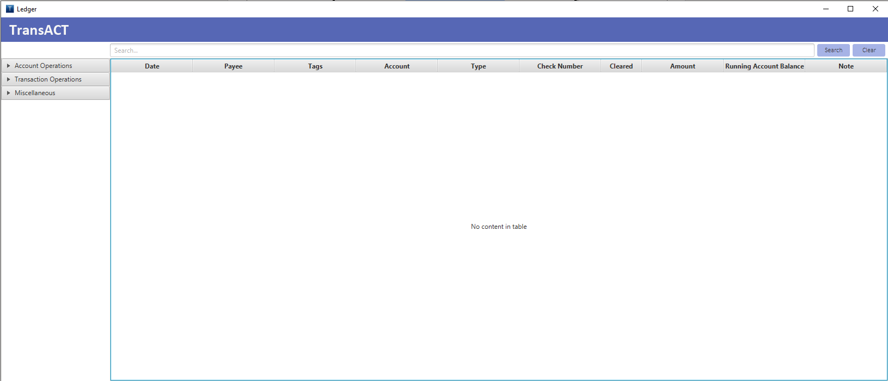

# Operations Tabs Overview

Three expandable and collapsible tabs on the left hand side of the application organize the application’s functionalities.

## Account Operations Tab

The first of the three operations tabs is the “Account Operations” tab. Upon expansion, the list view shown will house a list of all accounts that you have created, alongside an aggregation of all accounts. Selection of any item in this list view will filter the transaction table view to show only transactions in the selected account. Now note the buttons beneath the list of accounts. The “Add Account” button allows you to create new accounts, and the “Delete Account” button allows you to delete accounts.

## Transaction Operations Tab

Expanding the “Transaction Operations” tab shows three buttons. The “Add Transaction” button is used to access a window where the user can enter a single transaction manually into the transaction table. The “Import Transactions” button opens a window from which the user can bulk import transactions through a helpful interface. The “Add Automatic Tags” button opens a window that allows the user to associate different categorical tags with certain payees so that transactions with those payees are automatically tagged upon import.

## Miscellaneous Tab

The “Miscellaneous” tab encapsulates all of the application’s functionalities that don’t belong in the above two categories. The expansion of this tab shows three button. The first is “Analyze Finances” button. Clicking this will open a new window where the user can view charts that summarize the data in the transaction table on the main page. The charts can be filtered and dynamically interchanged to suit the user’s needs. Next is the “Export Data” button that allows users to save and export a database file to back up their data. This new file can be saved anywhere and is an exact copy of the current working database file. Finally the “Logout” button securely logs the user out of the current session, saving all data before exiting.

# Creating a New Account

The first thing you must do before importing or adding transactions is create a new account. This account can represent a savings account, checking account, or any other ‘account’ by which you wish to organize your finances. To create a new account, expand the “Account Operations” tab, and then click the “Add Account” button.

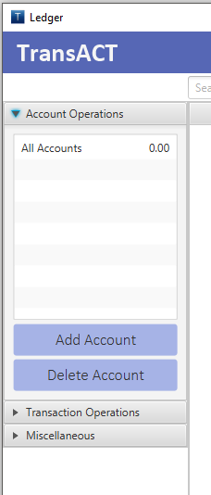

A window as shown below will appear. Give the new account a name, description, and numerical starting amount. Click “Submit as Complete” after populating all of the fields to finalize the account creation and return to the main page.

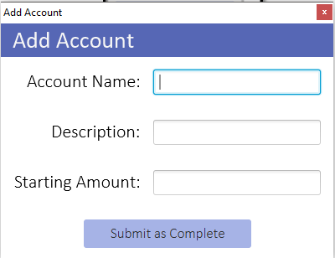

Notice that the newly created account is added to the account list in the “Account Operations” tab. The “All Accounts” aggregation now encompasses that new account as well.

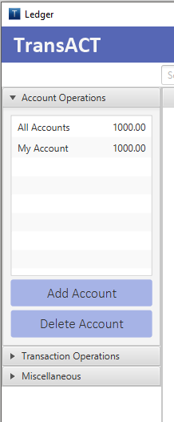

# Importing Transactions into an Account

Bank statements containing transaction histories can be downloaded from banks in CVS or QFX format. TransACT is compatible with a variety of different file formats. To import the transactions from such a file, first click on the “Import Transactions” button in the “Transaction Operations” tab.

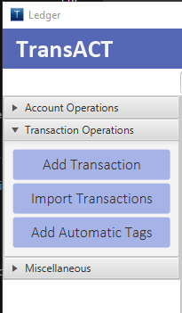

The window shown below will open. To begin, click the “Select File” button.

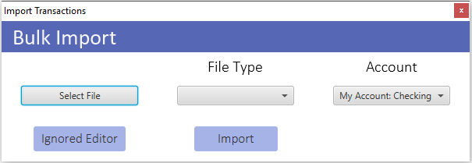

A file chooser window like that shown below will open. Navigate to where the file is located, and select it. Then click “Open”.

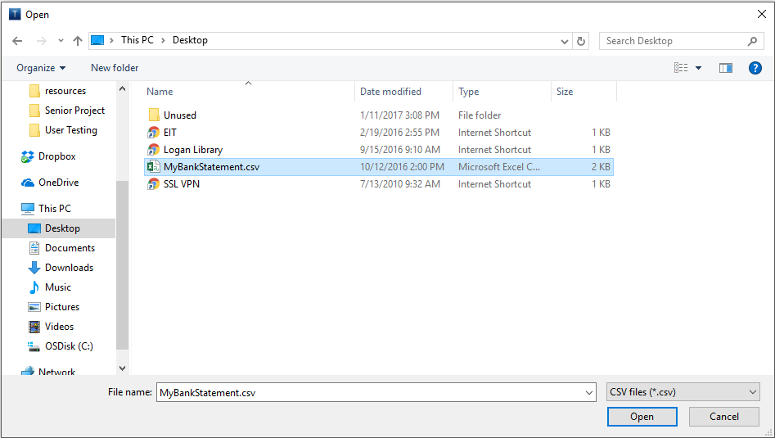

Next, select the file type from the “File Type” dropdown. Then select into what account the transactions will be imported from the “Account” dropdown. Clicking the “Import” button will then import the transactions from the selected file into the transaction table view on the main page. Optionally, clicking the “Ignored Editor” button will lead to a window where rules can be set to ignore certain transactions upon import.

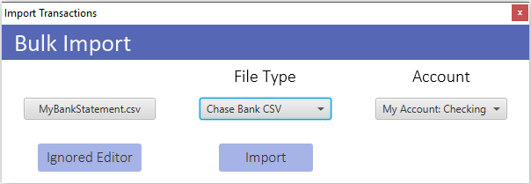

## Using the Ignored Editor

Rules can be made and persisted with the Ignored Transactions editor. Often there are certain types of transaction that show up on bank statements that the user wishes not to import. To ignore transactions such as these, first enter an expression that TransACT will use to look for the transactions to ignore. Often this is a payee name. State whether the expression should match or be contained within the payee field by selecting an option from the “Rule” dropdown. Click “Add” to add the rule to the table on the right hand side of the window. TransACT will now use this rule during the import process to set aside any transactions that match. When finished, exit out of the Ignored Editor and click the “Import” button on the “Bulk Import” window.

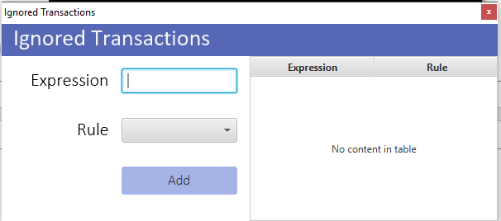

If TransACT comes across any transactions that match the rules in the Ignore Editor upon import, it will ask the user to review or discard them. A popup such as shown below will appear. Clicking the “Discard Transactions” button will automatically throw away all transactions caught by the Ignore Editor rules.

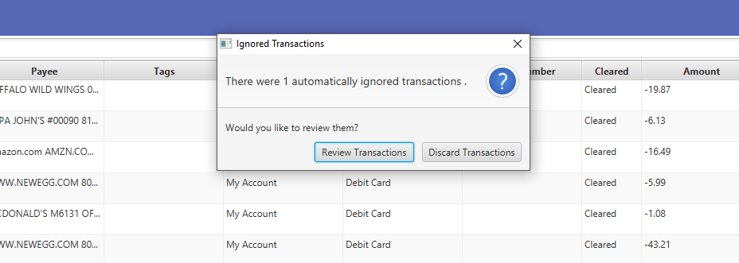

Clicking “Review Transactions” will prompt the user to review the caught transaction. A window will then appear, populated with all fields representing the transaction. These fields are editable if the user wishes to change aspects of the transaction. The user will then be given the option to skip or import each individual transaction. Skipping the transaction will throw it away, whereas importing it will import the singular transaction (and any modifications) into the transaction table view.

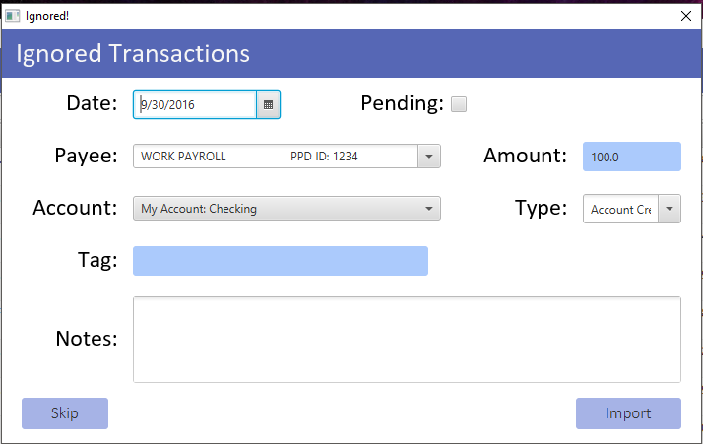

# Manually Adding Single Transactions

TransACT allows users to add single transactions by hand as well, as not all expenditures are captured by bank statements. There are two ways to add a single transaction to the transaction table view.

## Using the Add Transaction Window

The easiest way to add a single transaction would be to use the Add Transaction window. In the “Transaction Operations” tab, click the “Add Transaction” button, as shown below.



The Add Transaction window will then appear, as shown below. Fill in all required fields and click the “Add Transaction” button to finish and insert the transaction information into the table view. The Tag and Notes fields are not required, although they may assist with keeping track of useful information. Leaving the Pending checkbox unchecked declares that the transaction has been cleared.

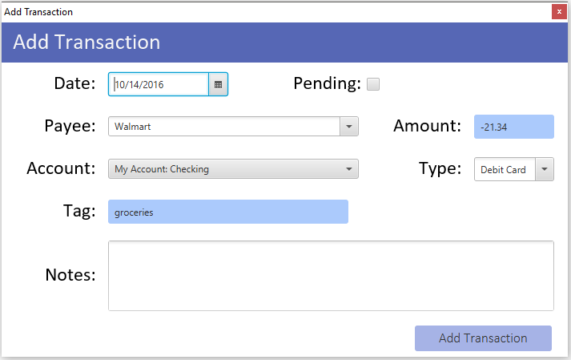

## Adding Transactions through the Right-Click Menu

The second way to insert a single transaction into the table view is through the right-click context menu. To do this, right-click over the transaction table view and select the “Add Transaction” option, shown below.

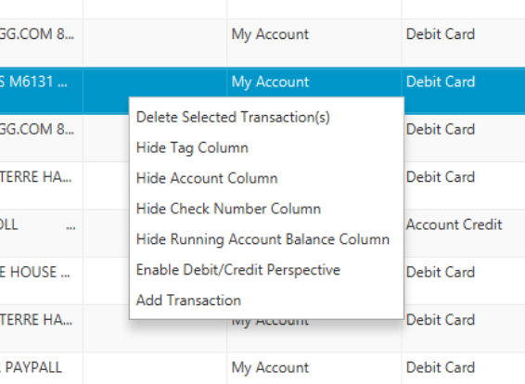

A new row will appear in the table. All fields are directly editable through the view. Simply fill in the same information that would have otherwise been entered into the Add Transaction window to create the same transaction record.



# Deleting

## Deleting Transactions

To delete one or more transactions, simply highlight the transactions that are to be deleted. Then, either select the “Delete Selected Transaction(s)” option from the right-click context menu (shown below), or press the Delete key on your computer’s keyboard.



## Deleting Accounts

To delete an entire account, select the account to be deleted from the account list in the Account Operations tab. Then, click the “Delete Account” button beneath the list.

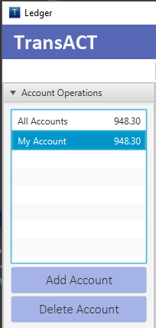

# Automatically Adding Tags to Imported Transactions

TransACT is capable of automatically applying tags to payees upon import. All the user needs to do is set up what tags they would like to associate with certain payees before importing their bank statements. To do this, first click on the “Add Automatic Tags” button in the Transaction Operations tab, shown below.



The Automatic Tagging window will appear with a list of all existing Payees and their descriptions, similar to what is shown below.

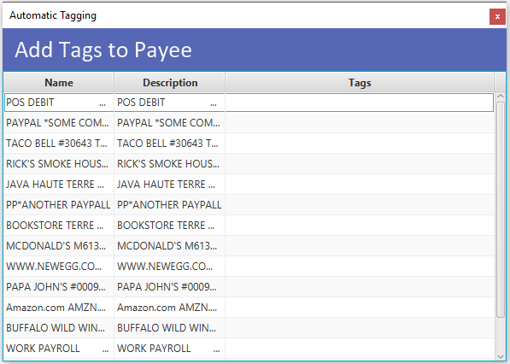

To add tags to payees, simply find the row representing the payee that is receiving a tag and click on the Tags column in that row. An “Add Tag” button will appear. Click it to add a single tag.

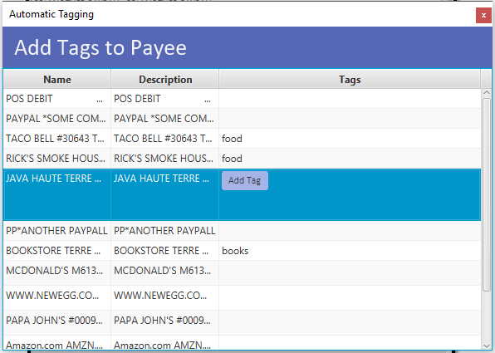

Enter the name of the tag into the resulting text box, and click the “Add” button when complete (shown below). This will associate that tag with that payee for all future imported transactions. Several tags may be added to and removed from each payee, if desired. To delete a tag, click on the tag and then click the “X” button that appears next to it.

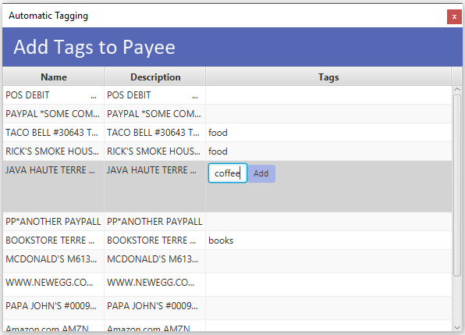

# Editing the Table View

The transaction table view is directly modifiable itself. Ten columns exist in the table view representing different transaction components, as can be seen below.

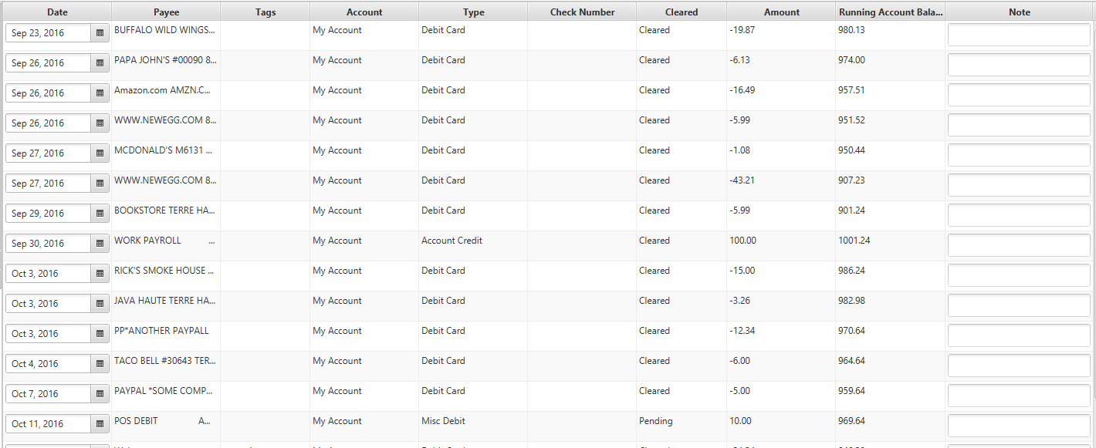

Eight of the ten columns are directly editable. To change data in the Date, Payee, Tags, Type, Check Number, Cleared, Amount, or Note columns, simply click on the table cell. Either a dropdown or an editable text field will appear in its place. For dropdowns, select the new value the transaction will have. For editable text fields, enter the desired information, and press the Enter key on your computer’s keyboard to save and continue.

Four columns can be hidden through the right-click context menu. The Tag, Account, Check Number, and Running Account Balance columns can be hidden by selecting their respective “Hide” option in the context menu, shown below. Columns can be shown again at any time through the context menu as well.



# Filtering Transactions

Transactions in the table view are filterable. Eight of the ten columns can be filtered by the Date, Payee, Account, Type, Check Number, Cleared, Amount, and Running Account Balance columns. The filtering is either chronological, alphabetical, or numerical in nature, depending on the data in that column. Click the gray column header above the column to sort the transactions according to that data.

## Filter by Search

The transaction table view is searchable as well. Above the table view there is a search box that dynamically searches the table as you type (shown below). Transactions in the table will filter all transactions to show only those that match the term being searched. Data in the Amount, Payee, and Tags columns are searchable via this method.



## Filter by Selecting an Account

The transaction table view can also be filtered by Account. By selecting an account in the account list view in the Account Operations tab (shown below), the transaction table will show only transactions in that account.

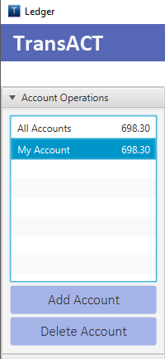

# Undoing Actions

You can undo any action at any time by pressing Ctrl + Z.

# Analyzing Finances

TransACT can help with financial analysis on top of record keeping. Using the data within the transactions, TransACT visualizes expenditure habits and trends with easy to read charts. To access these charts, click the “Analyze Finances” button within the Miscellaneous tab.

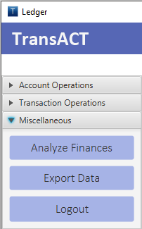

The Financial Analysis window will appear, showing the Expenditure Line Chart by default, as shown below. Using the controls on this window will allow the user to obtain a new look at their financial information.

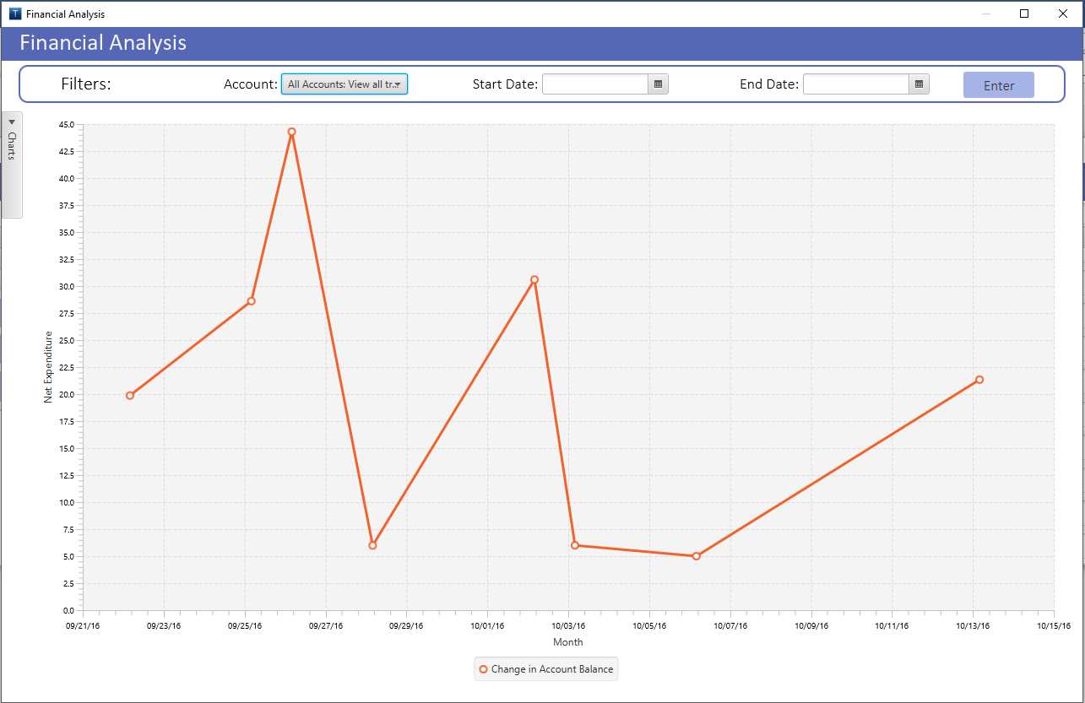

## Filtering

The Financial Analysis page allows all charts to be filtered by both date and account with the controls at the top of the page (shown below). Using the Account dropdown at the top of the page, the charts can show data from transactions originating in a single account or across all accounts. Start and end dates can be specified using the Start Date and End Date input fields to show only the transactions that occurred on and between those dates. To set filters, simply enter the desired data into these filter fields and click the “Enter” button. The Account and Date filters can be used independently of each other.



## Different Charts

TransACT currently supports five different charts. These charts can be accessed through the expandable pane on the left side of the screen. By checking and unchecking the boxes in the pane, the window can show any combination of the charts at once. These charts and their purposes will be described in this section.

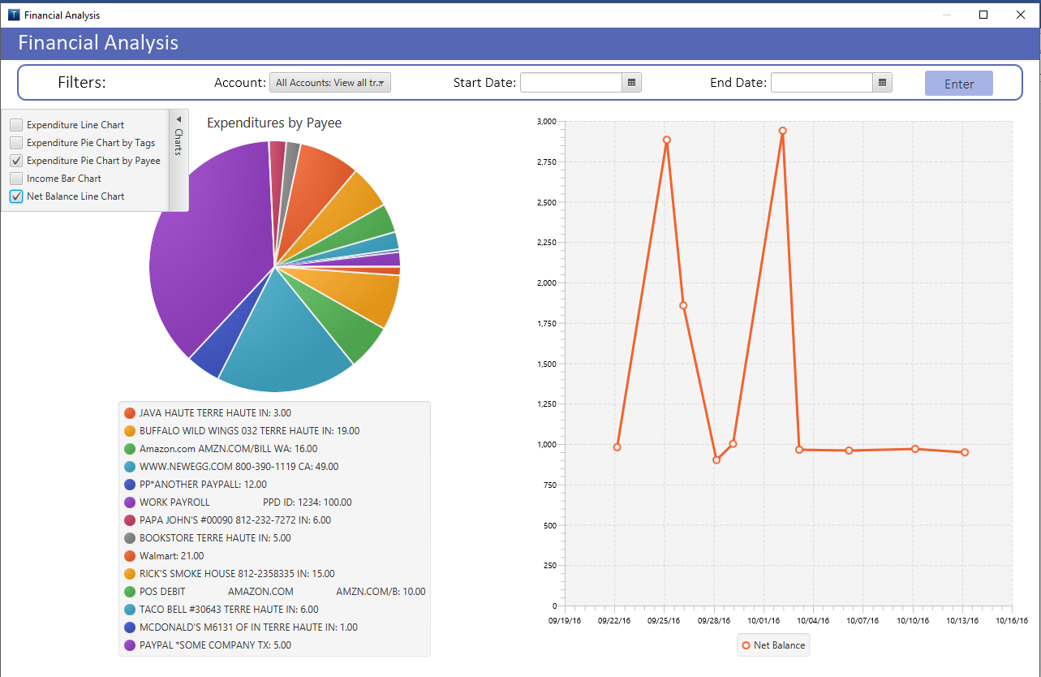

### Expenditure Line Chart

The Expenditure Line chart represents the flux of amount of money in the account(s) being analyzed. If more money comes in to the account(s) than goes out, the chart will show that net increase, and vice versa, over a set period.

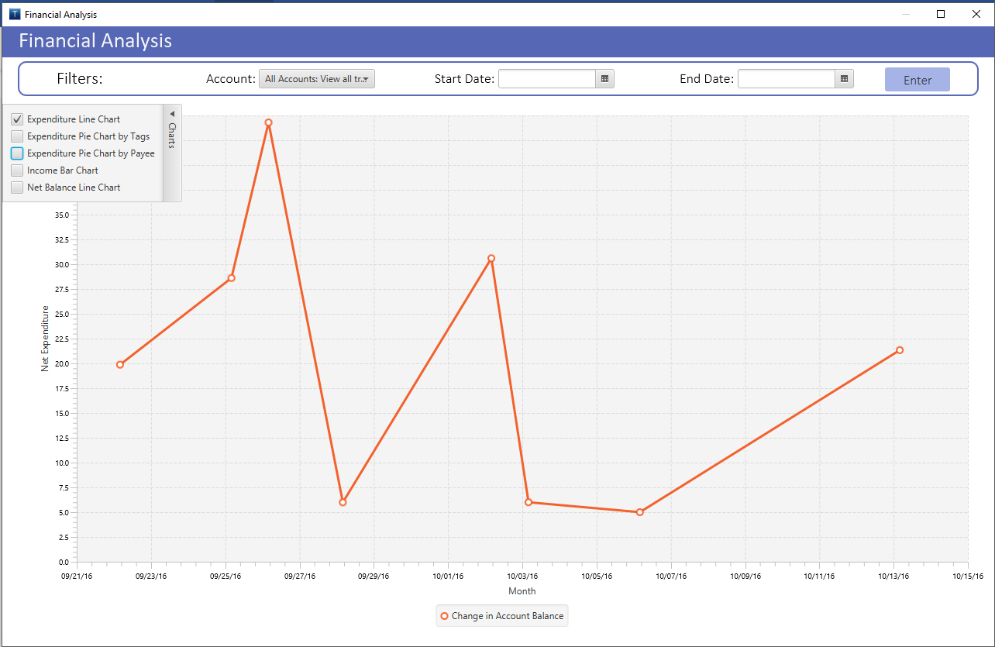

### Expenditure Pie Chart by Tags

The Expenditure Pie Chart by Tags shows proportions of expenditures determined by tagged transactions. This pie chart allows the user to visualize how much of their total expenditures went towards certain categories.

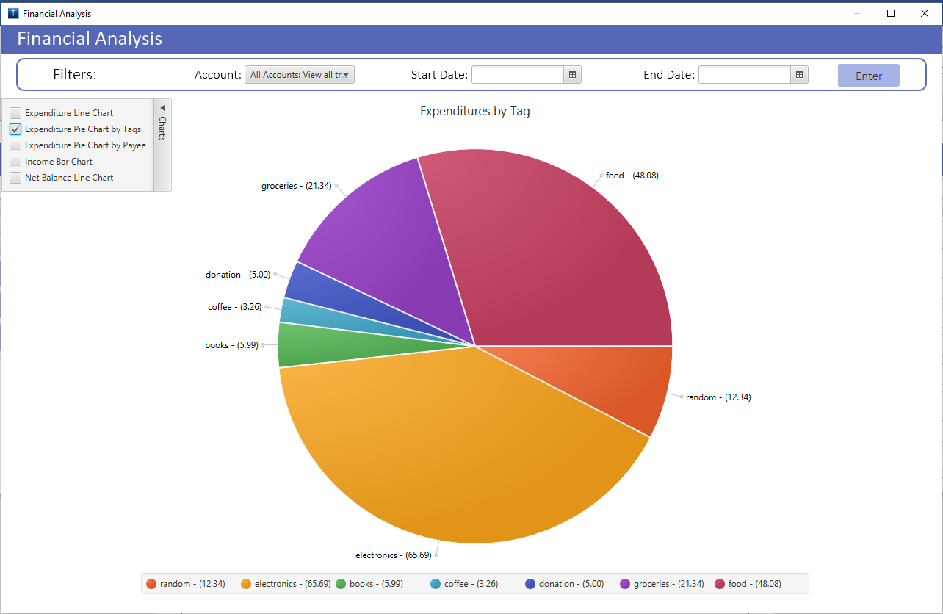

### Expenditure Pie Chart by Payee

The Expenditure Pie Chart by Payee shows proportions of expenditures according to payees. This helps the user see how much money they spend or make at any one place or for any one thing.

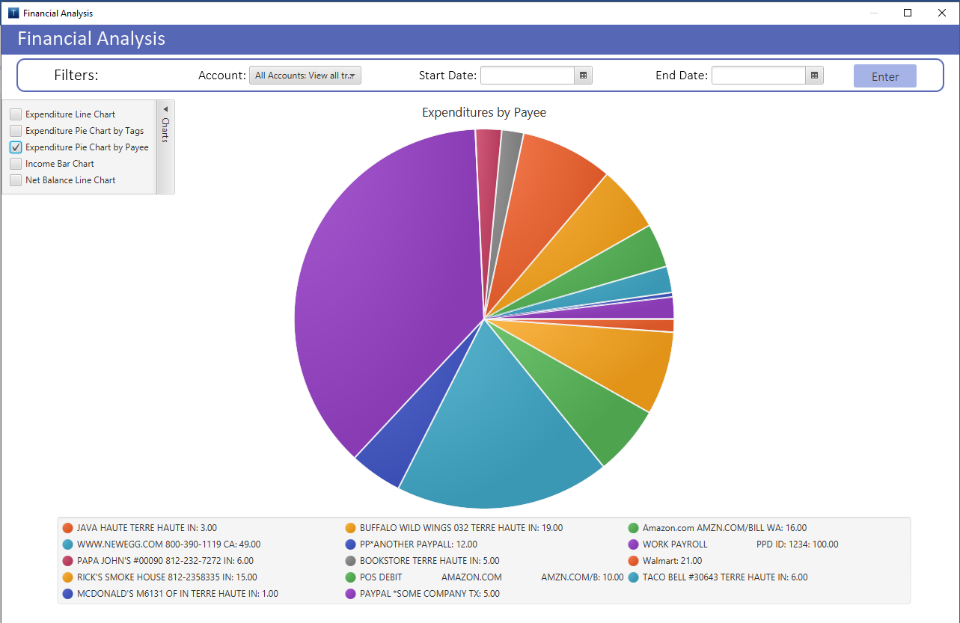

### Income Bar Chart

The Income Bar chart shows how much money made or placed into the account(s) being analyzed on a month-by-month basis.

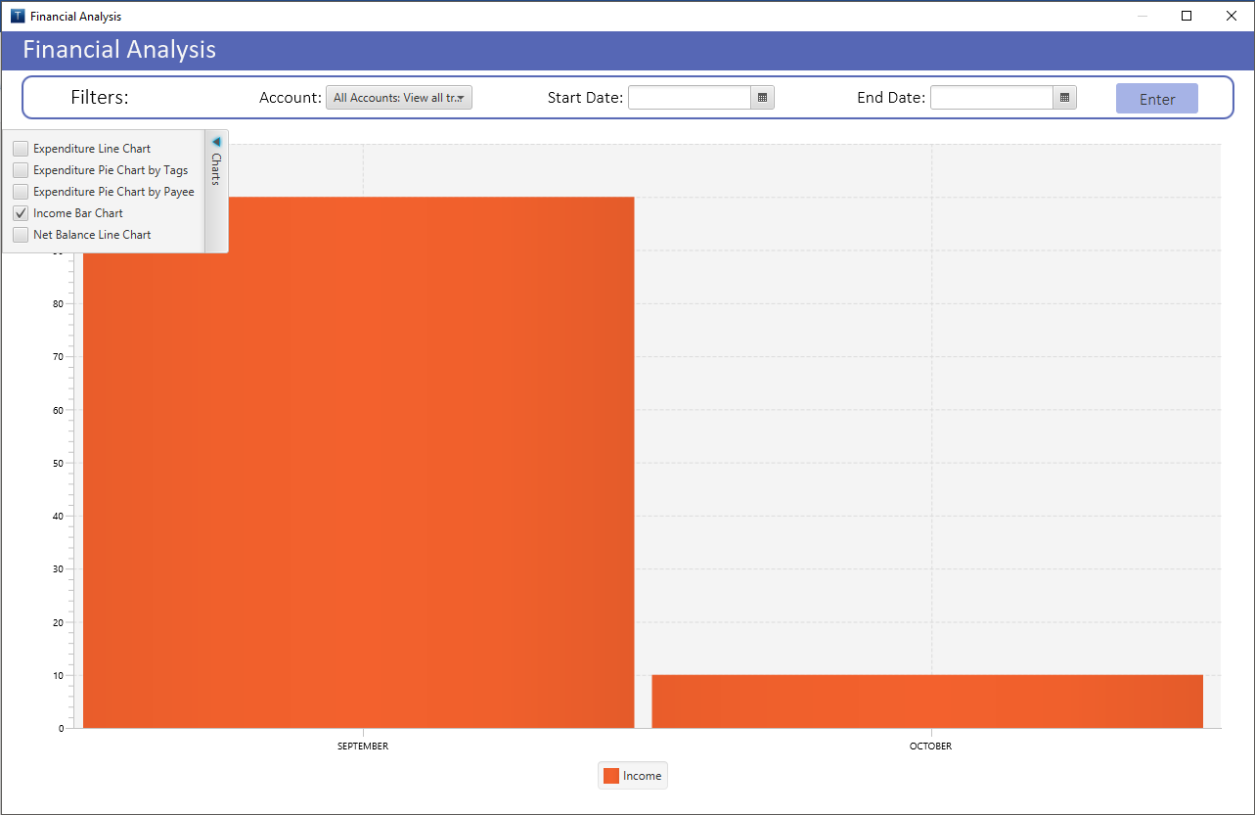

### Net Balance Line Chart

The Net Balance Line Chart shows the change in the overall balance of the account(s) being analyzed. The user can see the numerical balance of the account(s) at any point in time.

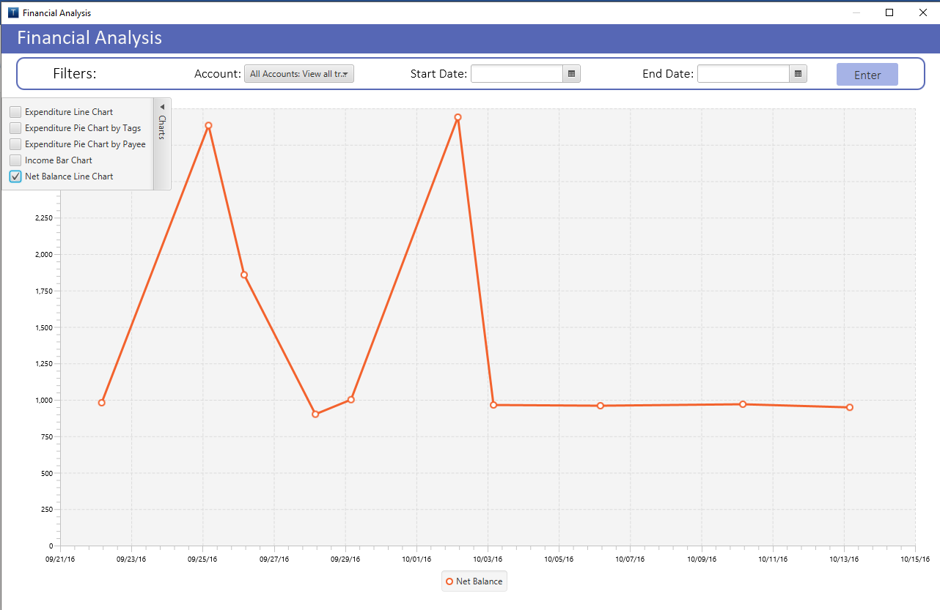

# Exporting Data

Exporting data will create a duplicate database file containing the same information as the one currently being used. This is useful for backing up records. To export data, click the “Export Data” button in the Miscellaneous tab.



A window similar to the one shown below will appear. Feel free to rename the file to something simple, otherwise, it will default to a string of numbers representing the date at which the data was exported. Select a place to save the file and click the “Save” button. This file can later be accessed like any other database file, using the same password that is securing the original database file and user session.

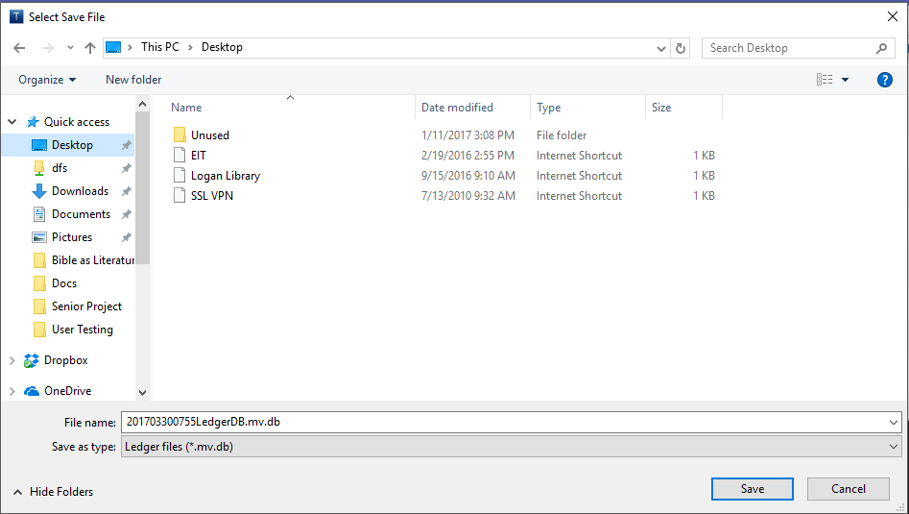

# Logging Out

Logging out of the application is simple. To logout and discontinue use with TransACT, click the “X” button in the upper corner of the application to shut it down. To return to the login page, click the “Logout” button in the Miscellaneous tab.



If the “Logout” button is pressed, you will return to the login page, with the previously used database file already loaded and the associated user session ready to be logged into (shown below).

